Write a PL/SQL block of code using parameterized Cursor that will merge the data available in

the newly created table N_Roll Call with the data available in the table O_RollCall. If the data

in the first table already exist in the second table then that data should be skipped.

**PL/SQL Block: -**

CREATE TABLE O_ROLLCALL(rollno NUMBER(10),name VARCHAR2(30),address VARCHAR2(30));

CREATE TABLE N_ROLLCALL(rollno NUMBER(10),name VARCHAR2(30),address VARCHAR2(30));

INSERT INTO O_ROLLCALL VALUES(1,'Khushal Patil','Dhule');

INSERT INTO O_ROLLCALL VALUES(2,'Yash Patil','Jalgaon');

INSERT INTO O_ROLLCALL VALUES(3,'Aayush Patil','Dhule');

INSERT INTO O_ROLLCALL VALUES(4,'Aryan Patil','Pune');

INSERT INTO O_ROLLCALL VALUES(5,'Chaitanya Mitkari','Pune');

INSERT INTO N_ROLLCALL VALUES(5,'Chaitanya Mitkari','Pune');

INSERT INTO N_ROLLCALL VALUES(6,'Tejas Danane','PUNE');

INSERT INTO N_ROLLCALL VALUES(7,'Gaurav Pawar','Kolhapur');

INSERT INTO N_ROLLCALL VALUES(8,'Pranav Patil','Jalgaon');

CREATE OR REPLACE PROCEDURE MERGE_ROLLCALLS IS

CURSOR ROLLCALL_CURSOR(P_ROLLNO O_ROLLCALL.ROLLNO%TYPE) IS

SELECT ROLLNO, NAME, ADDRESS FROM O_ROLLCALL WHERE ROLLNO = P_ROLLNO;

V_ROLLNO N_ROLLCALL.ROLLNO%TYPE;

V_NAME N_ROLLCALL.NAME%TYPE;

V_ADDRESS N_ROLLCALL.ADDRESS%TYPE;

V_ROWS_MERGED INTEGER := 0;

BEGIN

FOR RECORD IN (SELECT DISTINCT ROLLNO FROM O_ROLLCALL) LOOP

OPEN ROLLCALL_CURSOR(RECORD.ROLLNO);

LOOP

FETCH ROLLCALL_CURSOR INTO V_ROLLNO, V_NAME, V_ADDRESS;

EXIT WHEN ROLLCALL_CURSOR%NOTFOUND;

SELECT COUNT(*) INTO V_ROWS_MERGED FROM N_ROLLCALL WHERE ROLLNO = V_ROLLNO;

IF V_ROWS_MERGED = 0 THEN

INSERT INTO N_ROLLCALL (ROLLNO, NAME, ADDRESS)

VALUES (V_ROLLNO, V_NAME, V_ADDRESS);

END IF;

END LOOP;

CLOSE ROLLCALL_CURSOR;

END LOOP;

COMMIT;

DBMS_OUTPUT.PUT_LINE('RECORDS MERGED FROM O_ROLLCALL TO N_ROLLCALL.');

EXCEPTION

WHEN OTHERS THEN

ROLLBACK;

DBMS_OUTPUT.PUT_LINE('AN ERROR OCCURRED: ' || SQLERRM);

END;

/

SELECT * FROM O_ROLLCALL;

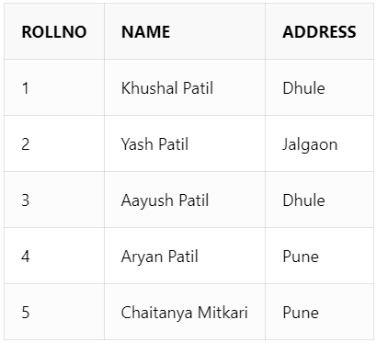

SELECT * FROM N_ROLLCALL;

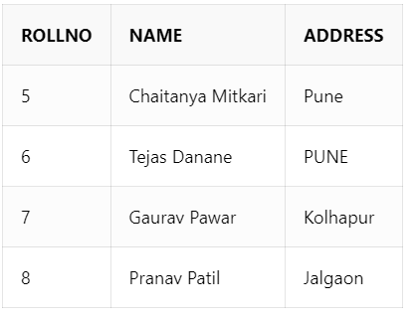

BEGIN

MERGE_ROLLCALLS;

END;

/

SELECT * FROM O_ROLLCALL;

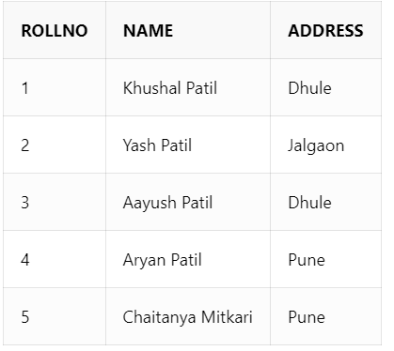

SELECT * FROM N_ROLLCALL ORDER BY ROLLNO;

